|  |  |
| --- | --- |
| Name | M.Faizan Azam, Muhammad Asad |
| Reg. # | 2019-EE-381,2019-EE-383 |
| Marks |  |

Experiment # 11

**Active Band Pass and Band Stop Filter**

# Objectives:

* To obtain the frequency response of an active band pass and band stop filter for desired cutoff frequency and verify the rolloff.

# Apparatus:

Op-amp 741, Capacitors, Resistors, DMM, CRO, Function Generator, Jumpers, Connecting wires, DC source, bread board

# Theory:

1. ***Band PassFilter:***

Active Band Pass Filter is slightly different in that it is a frequency selective filter circuit used in electronic systems to separate a signal at one particular frequency, or a range of signals that lie within a certain “band” of frequencies from signals at all other frequencies. This band or range of frequencies is set between two cut-off or corner frequency points labelled the “lower frequency” ( ƒL ) and the “higher frequency” ( ƒH ) while attenuating any signals outside of these two points. Simple Active Band Pass Filter can be easily made by cascading together a single Low Pass Filter with a single High Pass Filter asshown.

band pass filter design

The cut-off or corner frequency of the low pass filter (LPF) is higher than the cut-off frequency ofthehighpassfilter(HPF)andthedifferencebetweenthefrequenciesatthe-3dBpointwill

determine the “bandwidth” of the band pass filter while attenuating any signals outside of these points. One way of making a very simple Active Band Pass Filter is to connect the basic passive high and low pass filters we look at previously to an amplifying op-amp circuit as shown.

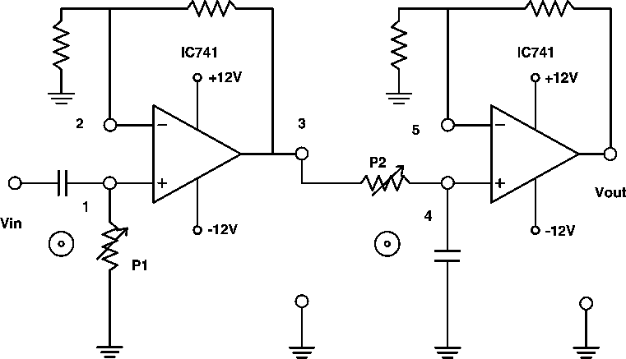

This cascading together of the individual low and high pass passive filters produces a low “Q- factor” type filter circuit which has a wide pass band. The first stage of the filter will be the high pass stage that uses the capacitor to block any DC biasing from the source. This design has the advantage of producing a relatively flat asymmetrical pass band frequency response with one half representing the low pass response and the other half representing high pass response as shown.

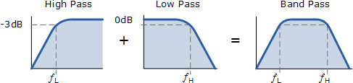

The higher corner point ( ƒH ) as well as the lower corner frequency cut-off point ( ƒL ) are calculated the same as before in the standard first-order low and high pass filter circuits. Obviously, a reasonable separation is required between the two cut-off points to prevent any

interaction between the low pass and high pass stages. The amplifier also provides isolation between the two stages and defines the overall voltage gain of the circuit.

The bandwidth of the filter is therefore the difference between these upper and lower -3dB points. For example, suppose we have a band pass filter whose -3dB cut-off points are set at 200Hz and 600Hz. Then the bandwidth of the filter would be given as: Bandwidth (BW) = 600 – 200 = 400Hz. The normalized frequency response and phase shift for an active band pass filter will be asfollows.

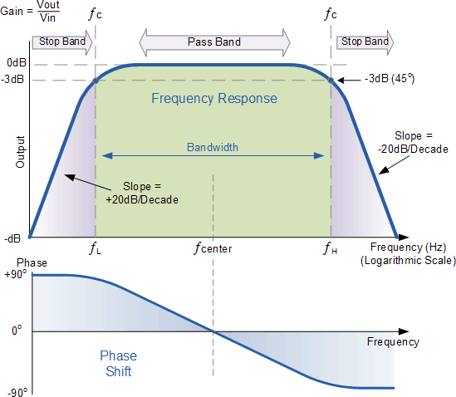

**Active Band Pass Frequency Response**

While the above passive tuned filter circuit will work as a band pass filter, the pass band (bandwidth) can be quite wide and this may be a problem if we want to isolate a small band of frequencies. Active band pass filter can also be made using inverting operational amplifier.

So by rearranging the positions of the resistors and capacitors within the filter we can produce a much better filter circuit as shown below. For an active band pass filter, the lower cut-off -3dB point is given by ƒC1 while the upper cut-off -3dB point is given by ƒC2.

# Band StopFilter:

The Band Stop Filter, (BSF) is another type of frequency selective circuit that functions in exactly the opposite way to the Band Pass Filter we looked at before. The band stop filter, also known as a band reject filter, passes all frequencies with the exception of those within a specified stop band which are greatly attenuated.

If this stop band is very narrow and highly attenuated over a few hertz, then the band stop filter is more commonly referred to as a notch filter, as its frequency response shows that of a deep notch with high selectivity (a steep-side curve) rather than a flattened wider band.

Also, just like the band pass filter, the band stop (band reject or notch) filter is a second-order (two-pole) filter having two cut-off frequencies, commonly known as the -3dB or half-power points producing a wide stop band bandwidth between these two -3dB points.

Then the function of a band stop filter is too pass all those frequencies from zero (DC) up to its first (lower) cut-off frequency point ƒL, and pass all those frequencies above its second (upper) cut-off frequency ƒH, but block or reject all those frequencies in-between. Then the filters bandwidth, BW is defined as: (ƒH – ƒL).

For a wide-band band stop filter, the filters actual stop band lies between its lower and upper - 3dB points as it attenuates or rejects any frequency between these two cut-off frequencies. The frequency response curve of an ideal band stop filter is therefore given as:

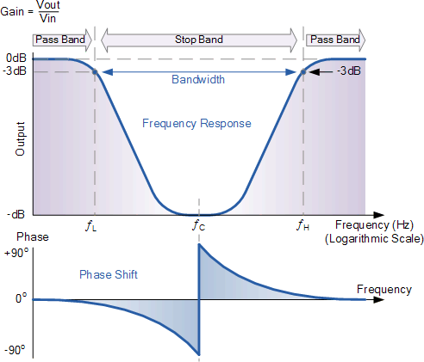

We can see from the amplitude and phase curves above for the band pass circuit, that the quantities ƒL, ƒH and ƒC are the same as those used to describe the behaviour of the band-pass filter. This is because the band stop filter is simply an inverted or complimented form of the standard band-pass filter. In fact the definitions used for bandwidth, pass band, stop band and center frequency are the same as before, and we can use the same formulas to calculate bandwidth, BW, center frequency, ƒC, and quality factor, Q.

The ideal band stop filter would have infinite attenuation in its stop band and zero attenuation in either pass band. The transition between the two pass bands and the stop band would be vertical (brick wall). There are several ways we can design a “Band Stop Filter”, and they all accomplish the same purpose.

Generally band-pass filters are constructed by combining a low pass filter (LPF) in series with a high pass filter (HPF). Band stop filters are created by combining together the low pass and high pass filter sections in a “parallel” type configuration as shown.

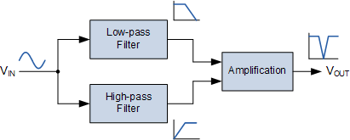

The summing of the high pass and low pass filters means that their frequency responses do not overlap, unlike the band-pass filter. This is due to the fact that their start and ending frequencies are at different frequency points. For example, suppose we have a first-order low-pass filter with a cut-off frequency, ƒL of 200Hz connected in parallel with a first-order high-pass filter with a cut-off frequency, ƒH of 800Hz. As the two filters are effectively connected in parallel, the input signal is applied to both filters simultaneously as shown above.

All of the input frequencies below 200Hz would be passed unattenuated to the output by the low- pass filter. Likewise, all input frequencies above 800Hz would be passed unattenuated to the output by the high-pass filter. However, and input signal frequencies in-between these two frequency cut-off points of 200Hz and 800Hz, that is ƒL to ƒHwould be rejected by either filter forming a notch in the filters output response.

In other words a signal with a frequency of 200Hz or less and 800Hz and above would pass unaffected but a signal frequency of say 500Hz would be rejected as it is too high to be passed by the low-pass filter and too low to be passed by the high-pass filter. We can show the effect of this frequency characteristic below.

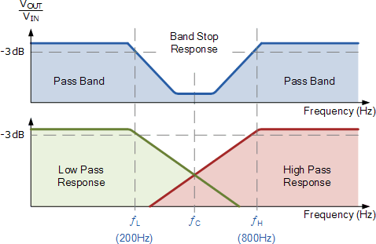

The transformation of this filter characteristic can be easily implemented using a single low pass and high pass filter circuits isolated from each other by non-inverting voltage follower, (Av = 1). The output from these two filter circuits is then summed using a third operational amplifier connected as a voltage summer (adder) as shown.

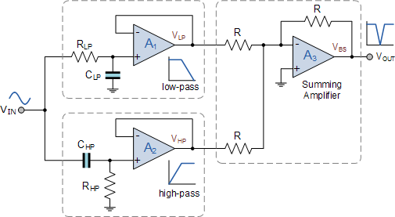

The use of operational amplifiers within the band stop filter design also allows us to introduce voltage gain into the basic filter circuit. The two non-inverting voltage followers can easily be converted into a basic non-inverting amplifier with a gain of Av = 1 + Rƒ/Rin by the addition of input and feedback resistors, as seen in our non-inverting op-amp tutorial. Also if we require a band stop filter to have its -3dB cut-off points at say, 1kHz and 10kHz and a stop band gain of -

10dB in between, we can easily design a low-pass filter and a high-pass filter with these requirements and simply cascade them together to form our wide-band band-pass filter design.

# General Procedure:

1. ***Band PassFilter:***
   * Set up the circuit band passfilter.
   * Design the filter for a gain of 1.586 and make the connections as of circuit diagram of BPF.
   * Set he signal generator amplitude of 100 mV (p-p) and observe the input voltage and output voltage onCRO
   * By varying the frequency of input from 50 Hz to 5 KHz range note down the frequency and corresponding output voltage across pin 6 of the op amp with respect to thegnd.
   * The output voltage remains constant at lowerfrequency.
   * Tabulate the readings in tabularform.
   * Plot the graph with ‘f’ on X-axis and gain in dB on Yaxis.

# Band StopFilter:

* + Set up the circuit band passfilter.
  + Design the two filters for the desire cutoff frequencies and make the connections as of circuit diagram ofBSF.
  + Set he signal generator amplitude of 100 mV (p-p) and observe the input voltage and output voltage onCRO
  + By varying the frequency of input from 50 Hz to 5 KHz range note down the frequency and corresponding output voltage across pin 6 of the op amp with respect to thegnd.
  + The output voltage remains constant at lowerfrequency.
  + Tabulate the readings in tabularform.
  + Plot the graph with ‘f’ on X-axis and gain in dB on Yaxis.

# Design:

Design the BPF and BSF with given range of frequency and find out the amplitude and draw the graph. The formulas are

1)BW=1/𝜋R3C

2)Go=R3/2R1

3) f0=1/2𝜋𝐶√(𝑅1//𝑅2)𝑅3

4) Q=f0/BW

# Circuit:

1. ***Band PassFilter:***

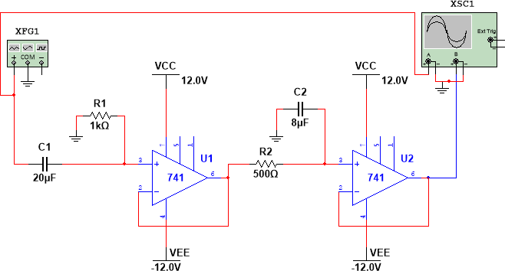

***Calculations:***

fcl = 1/2*pi*RC

fcl = 1/2*3.14*1000*0.000020

fcl = 7.96

fch = 1/2*pi*RC

fch = 1/2*3.14*500*0.000008

fch = 39.8

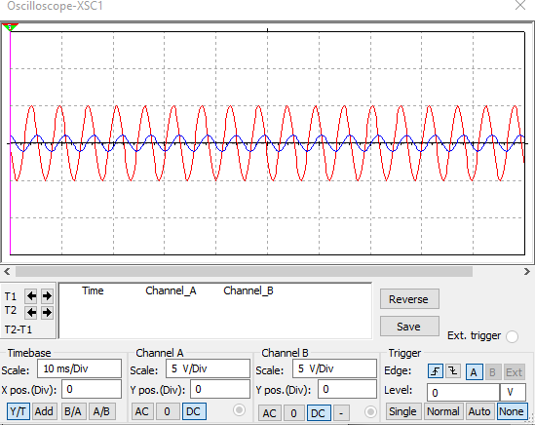***Graph:***

***Result:***

|  |  |  |
| --- | --- | --- |
| Sr.# | **Frequency** | **Gain** |
| 01 | 50 | 1.25mV |
| 02 | 60 | 1.4mV |
| 03 | 70 | 1.28mV |
| 04 | 90 | 1.29mV |
| 05 | 100 | 1.33Mv |
| 06 | 120 | 1.38mV |

1. ***Band StopFilter:***

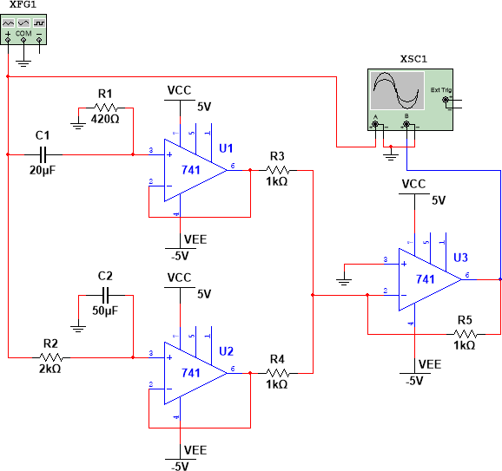

***Calculations:***

fcl = 1/2*pi*RC

fcl = 1/2*3.14*2000*0.000050

fcl = 1.59

fch = 1/2*pi*RC

fch = 1/2*3.14*420*0.000020

fch = 18.96

***Graph:***

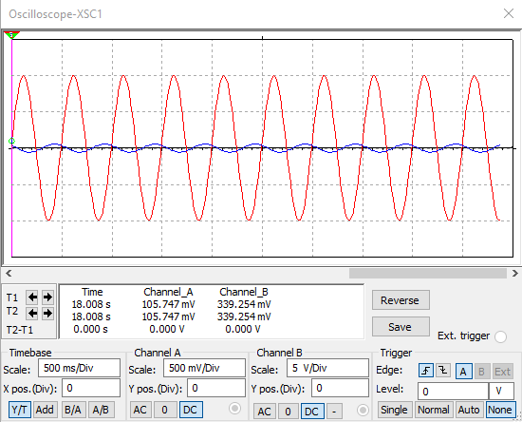

***Result:***

|  |  |  |
| --- | --- | --- |
| Sr.# | **Frequency** | **Gain** |
| 01 | 50 | 1.23mV |
| 02 | 60 | 1.3mV |
| 03 | 70 | 1.22mV |
| 04 | 90 | 1.23mV |
| 05 | 100 | 1.31Mv |
| 06 | 120 | 1.31mV |
| 07 | 140 | 1.38mV |

***Questions:***

## Which filter attenuates any frequency outside the passband?

A band pass filter has a pass band between two cut-off frequencies fH and fL. So, any frequency outside this pass band is attenuated.

## Write down two uses of band passfilter?

Band pass filters are used in many applications including wireless transmitters to limit the bandwidth of the output signal to the minimum necessary.

## Write down two uses of band stopfilter?

In signal processing, a band-stop filter or band-rejection filter is a filter that passes most r fequencies unaltered, but attenuates those in a specific range to very low levels. It is the o opposite of a band-passfilter.

## What is filter rolloff?

Specifically roll off refers to the action of a specific type of filter; one designed to roll off f frequencies above or below a certain point. It is called roll off because the process is

g gradual.